# Next Steps and Data Sources

Next Steps

1. Actively engage Facilities Services in the System.
2. Automate select streams of data so they are not all being manually uploaded (see data flow and data sources on the next page). This includes:
   1. Pulling waste creation data from the Office of Sustainability’s Google Sheet
      1. HTML Interface may be a solution
      2. May be able to download the information as a text file saved to a specific location where it could be uploaded to the database through an interface automatically
   2. PPL electricity usage data
      1. Using the HTML interface to pull information from a customer portal or online billing statement may be a solution
      2. Creating an interface to take the data right from PPL into the Sustainability database may be a solution
   3. UGI gas usage data
      1. Using the HTML interface to pull information from a customer portal or online billing statement may be a solution
      2. Creating an interface to take the data right from PPL into the Sustainability database may be a solution
   4. Bethlehem Municipal water usage data
      1. Using the HTML interface to pull information from a customer portal or online billing statement may be a solution
      2. Creating an interface to take the data right from PPL into the Sustainability database may be a solution
3. Begin manually uploading data
4. Making future edits to the PI Vision displays
   1. PI Vision Permission – Receive permission from Alex Pacheco to edit and create displays on Lehigh’s PI Vision platform for the appropriate users in the Office of Sustainability

Data Sources

Current data flow (1/17/19) for information in the PI System:

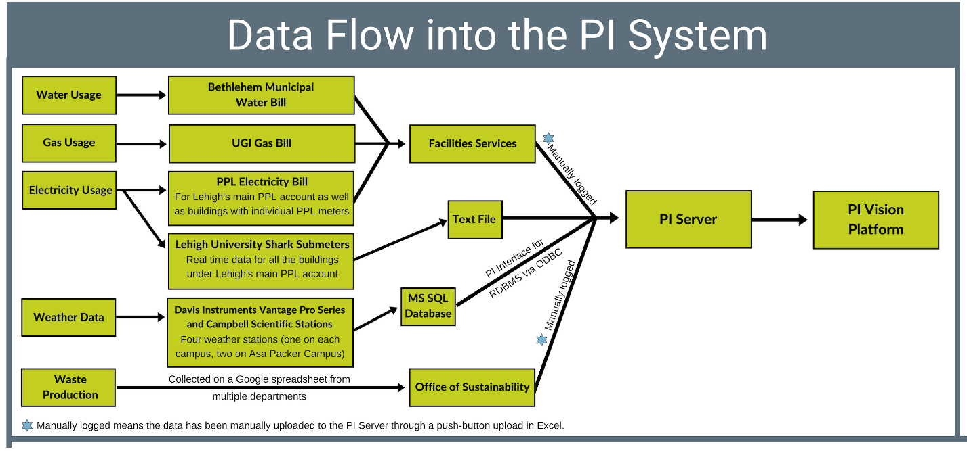

1. Waste Creation Data:
   1. Individual departments receive invoices
   2. Individual departments input data into a shared Google Sheet to compile all the data together
   3. Compiled data is manually uploaded to the PI System through the UFL Connector
2. Electricity Usage Data:
   1. Smart Shark Meters: Most of Lehigh’s buildings are under a single PPL account. The buildings underneath this account have smart Shark Electricity Meters which upload data to the PI System in real time
   2. PPL Electricity Bill: All buildings which do not have smart meters receive bills for electricity use from the distributor PPL. A member of Facilities Services currently takes that information from a bill and manually logs it into an Excel spreadsheet
   3. For the time being this data is being uploaded to the PI System through the UFL Connector
3. Water Usage Data:
   1. Bethlehem Municipal Water Bill: A member of Facilities Services currently takes this information from a bill and manually logs it into an Excel spreadsheet
   2. For the time being this data is being uploaded to the PI System through the UFL Connector
4. Gas Usage Data:
   1. UGI Gas Bill: A member of Facilities Services currently takes this information from a bill and manually logs it into an Excel spreadsheet
   2. For the time being this data is being uploaded to the PI System through the UFL Connector
5. Weather Data:
   1. Weather data is **not** currently being logged to the PI System. Plans for its integration into the PI System can be found on the next several pages.

**Weather Station Data Transition Plans**

# Background:

Weather Stations

* Lehigh University Weather Stations
  + Asa Packer Campus STEPS 1 Davis Instruments Vantage Pro2
  + Asa Packer Campus STEPS 2 Davis Instruments Vantage Pro2
  + Asa Packer Campus STEPS (additional) Supplementary Vantage Pro Sensors:

Soil Moisture

Soil Temperature

Leaf Wetness

* + Goodman Campus Weather Station Campbell Scientific Data Logger
  + Mountaintop Campus Weather Station Davis Instruments Vantage Pro2
* Pocono Weather Stations
  + Lake Lacawac Weather Station Campbell Scientific Data Logger
  + Lake Weather Station Campbell Scientific Data Logger
  + Lacawac Sanctuary U. V. Station Campbell Scientific Data Logger
* Lehigh Gap Nature Center Weather Stations
  + East Ridge Microclimate Station Unknown
  + West Ridge Microclimate Station Unknown
  + LGNC Microclimate Station Unknown
  + LNE Old Bridge Microclimate Station Unknown

The weather stations with Campbell Scientific Data Loggers log their data to the Lehigh network directly, and the weather stations with Davis Instruments Vantage Pro Sensors log their data to the Lehigh network through Envoy 8x Receivers (1 for all the STEPS sensors and 1 for the Mountaintop Campus Weather Station).

### Plans:

Currently Dr. Bruce Hargreaves maintains the weather stations. Additionally Dr. Hargreaves manages all the weather station data from a remote desktop login to the computer actively collecting the data on campus. He processes the data and completes his analyses from this remote desktop by exporting a monthly CSV file for each weather station from the Davis software and adding it to an Excel template file. The weather stations currently log their data to separate Microsoft DataAccess files generated when the data sends to the computer.

In order to integrate the data into the PI System to empower Lehigh students and staff through the Lehigh University Campus Metabolism Database, the data collected should not have to generate DataAccess files. The weather stations can switch from generating Microsoft DataAccess files to logging data to Microsoft SQL Database tables. By switching, the data can upload to the PI Server utilizing the PI Interface for RDMS via ODBC or utilizing the native interfaces for the equipment.

## Option One: PI Interface for Davis Instruments Vantage Pro/Pro Plus

Utilizing the PI Interface for Davis Instruments Vantage Pro/Pro Plus to upload data

Advantages:

* Direct data import from the weather stations into the PI System
* The native interfaces will be able to handle the data resolution and the robustness of the imports
* Holds up better overtime, in terms of the quality of data and the quality of imports

Disadvantages:

* Not all the weather stations would be importing data into the PI System on the same interface

The first part of Option Plan One consists of installing the PI Interface for Davis Instruments Vantage Pro/Pro Plus onto the interface node currently collecting the weather station data. Utilizing a native interface for the devices may prove to be beneficial over utilizing the PI Interface for RDBMS via ODBC (Relational Database Management System that supports Open Database Connectivity drivers) depending on the resolution of the created SQL table. If the SQL table does not have robust mechanisms to import and maintain the data every fifteen minutes, it would be more beneficial to utilize the native interface in order to maintain data quality and the frequency of import.

The second part of Option Plan One consists of making a decision between:

1. Utilizing a native interface for the Campbell Scientific Data Loggers (PI Interface for Campbell Scientific LoggerNet) right away,
2. Setting up a Miscrosoft SQL database to collect the data coming from the Campbell Scientific Data Loggers now and later configuring the PI Interface for Campbell Scientific LoggerNet to collect the data,
3. Setting up a Microsoft SQL database to collect the data coming from the Campbell Scientific Data Loggers

*Requirements for PI Interface for Davis Instruments Vantage Pro/Pro Plus:

All information verifiable in the PI Interface for Davis Instruments Vantage Pro/Pro Plus User Guide

* Compatible Devices:
  + Vantage Pro
  + Vantage Pro Plus
  + Vantage Pro2
  + Vantage Pro2 Plus
* Compatible Platforms:
  + Windows NT 4.0 SP6a
  + Windows 2000 SP4
  + Windows XP SP2
  + Windows 2003 SP1
* The Interface requires one of the following combinations of hardware from Davis Instruments:
  + Remote data measurement sensors (e.g., outside temperature and wind)
  + Davis Instruments Vantage Pro/Plus Weather Station Console (for retrieving data from the remote sensors)
  + Davis Instruments Data Logger (for enabling communications between the weather console and the computer on which this Interface runs)

OR

* + Remote data measurement sensors (e.g., outside temperature and wind)
  + Davis Instruments Weather Envoy (for retrieving data from the remote sensors)
  + Davis Instruments Data Logger (for enabling communications between the Weather Envoy and the computer on which this Interface runs)

**PI Interface for Davis Instruments Vantage Pro/Pro Plus** **Overall:**

* The Data Logger (a hardware connection tool which comes with the Davis Instruments WeatherLink software kit) must be utilized
  + Note: Dr. Hargreaves stated he uses Envoy8x Receivers to send and collect the data. Check whether that process also utilizes the data logger.
* Even if the Davis Instruments Weather Envoy is in use, the Data Logger is still required. The Weather Envoy retrieves data from the sensors and sends it via the Data Logger to the computer.
* The VantagePro.dll, which is available free of charge from the Davis Instrument web site, is required. Data is retrieved from the weather station using the API (Application Programming Interface) provided in the VantagePro.dll, so it must be installed on the interface computer.
* Each copy of the interface connects via one serial port to one weather station (or Weather Envoy)

*Requirements for PI Interface for Campbell Scientific LoggerNet

All information verifiable in the PI Interface for Campbell Scientific LoggerNet User Guide

* Compatible Platforms:
  + Windows Vista (32-bit & 64-bit)
  + Windows 2008 (32-bit & 64-bit)
  + Windows 2008 R2 (64-bit)
  + Windows 7 (32-bit & 64-bit)
  + Windows 8.1 (64-bit)
  + Windows 10 (64-bit)
* Required Software:
  + LoggerNet SDK controls (version 4.0 or higher, CSI# 16756)
  + Scientific’s LoggerNet or LoggerNet Admin Datalogger Support Software

**PI Interface for Campbell Scientific LoggerNet Overall:**

* The PI Interface for Campbell Scientific LoggerNet System transfers data from the Campbell Scientific’s LoggerNet Server system to the PI Data Archive. The interface interacts with the Campbell Scientific’s LoggerNet Software Development Kit (SDK) (CSI# 16756) which is included in the interface setup kit.

**Data Flow:**

1. Utilizing both native Interface options

Davis Instruments Vantage Pro Weather Stations

Campbell Scientific Data Logger Weather Stations

PI Server

PI Interface for Davis Instruments Vantage Pro/Pro Plus

PI Interface for Campbell Scientific LoggerNet

1. Utilizing the native Interface for Davis Instruments and a SQL Database for Campbell Scientific

Davis Instruments Vantage Pro Weather Stations

Campbell Scientific Data Logger Weather Stations

PI Server

Microsoft SQL Database

PI Interface for Davis Instruments Vantage Pro/Pro Plus

PI Interface for

RDBMS via ODBC

## Option Two: PI Interface for RDBMS via ODBC Short-Term

Option Plan Two consists of two parts:

1. Setup the PI Interface for RDBMS via ODBC right away in order to import data from the Microsoft SQL Database into the PI System
2. Later down the line configure the PI Interface for Davis Instruments Vantage Pro/Pro Plus to import data directly from the weather stations into the PI System, and keep the weather stations with Campbell Scientific Data Loggers in the Microsoft SQL Database

OR

1. Setup the PI Interface for RDBMS via ODBC right away in order to import data from the Microsoft SQL Database into the PI System
2. Later down the line configure both the PI Interface for Davis Instruments Vantage Pro/Pro Plus and the PI Interface for Compbell Scientific LoggerNet to import data directly from the weather stations into the PI System.

*Option Plan One outlines some of the major requirements for both the native interfaces.

**Data Flow:**

1. PI Interface for RDBMS via ODBC

Davis Instruments Vantage Pro Weather Stations

Campbell Scientific Data Logger Weather Stations

Microsoft SQL Database

PI Server

PI Interface for

RDBMS via ODBC

1. Native Weather Station Options

Davis Instruments Vantage Pro Weather Stations

Campbell Scientific Data Logger Weather Stations

PI Server

Microsoft SQL Database

PI Interface for Davis Instruments Vantage Pro/Pro Plus

PI Interface for

RDBMS via ODBC

OR

Davis Instruments Vantage Pro Weather Stations

Campbell Scientific Data Logger Weather Stations

PI Server

PI Interface for Davis Instruments Vantage Pro/Pro Plus

PI Interface for Campbell Scientific LoggerNet

## Option Three: PI Interface for RDBMS via ODBC Long-Term

Option Plan Three: Setup the PI Interface for RDBMS via ODBC in order to import data from the Microsoft SQL Database into the PI System

Advantages:

* All the weather stations would be importing data into the PI System on the same interface, creating a simpler data flow

Disadvantages:

* Data needs to travel through multiple programs: From weather station, through Weather Envoy8x Receiver, into the SQL Database, through the PI Interface for RDBMS via ODBS, into the PI System’s Data Archive
* Depending on the resolution of the SQL Database and the robustness of its import mechanisms, it may not be as reliable of a data importer in the long-term

**Data Flow:**

Davis Instruments Vantage Pro Weather Stations

Campbell Scientific Data Logger Weather Stations

Microsoft SQL Database

PI Server

PI Interface for

RDBMS via ODBC